ABSTRACT:
With the character of low maintenance, cloud computing provides an economical and efficient solution for sharing group resource among cloud users. Unfortunately, sharing data in a multi-owner manner while preserving data and identity privacy from an untrusted cloud is still a challenging issue, due to the frequent change of the membership. In this paper, we propose a secure multi owner data sharing scheme, named Mona, for dynamic groups in the cloud. By leveraging group signature and dynamic broadcast encryption techniques, any cloud user can anonymously share data with others. Meanwhile, the storage overhead and encryption computation cost of our scheme are independent with the number of revoked users. In addition, we analyze the security of our scheme with rigorous proofs, and demonstrate the efficiency of our scheme in experiments.
EXISTING SYSTEM:
Several security schemes for data sharing on untrusted servers have been proposed. In these approaches, data owners store the encrypted data files in untrusted storage and distribute the corresponding decryption keys only to authorized users. Thus, unauthorized users as well as storage servers cannot learn the content of the data files because they have no knowledge of the decryption keys However, the complexities of user participation and revocation in these schemes are linearly increasing with the number of data owners and the number of revoked users, respectively. By setting a group with a single attribute, Lu et al. proposed a secure provenance scheme based on the ciphertext-policy attribute-based encryption technique, which allows any member in a group to share data with others. However, the issue of user revocation is not addressed in their scheme. Yu et al. presented a scalable and fine-grained data access control scheme in cloud computing based on the key policy attribute-based encryption (KP-ABE) technique. Unfortunately, the single owner manner hinders the adoption of their scheme into the case, where any user is granted to store and share data.

DISADVANTAGES OF EXISTING SYSTEM:
- Identity privacy is one of the most significant obstacles for the wide deployment of cloud computing. Without the guarantee of identity privacy, users may be unwilling to join in cloud computing systems because their real identities could be easily disclosed to cloud providers and attackers. On the other hand, unconditional identity privacy may incur the abuse of privacy.
- It is highly recommended that any member in a group should be able to fully enjoy the data storing and sharing services provided by the cloud, which is defined as the multiple-owner manner. Compared with the single-owner manner, where only the group manager can store and modify data in the cloud, the multiple-owner manner is more flexible in practical applications.
- Groups are normally dynamic in practice, e.g., new staff participation and current employee revocation in a company. The changes of membership make secure data sharing extremely difficult.
PROPOSED SYSTEM:
In this paper, we propose a secure multiowner data sharing scheme, named Mona, for dynamic groups in the cloud. By leveraging group signature and dynamic broadcast encryption techniques, any cloud user can anonymously share data with others. Meanwhile, the storage overhead and encryption computation cost of our scheme are independent with the number of revoked users. In addition, we analyze the security of our scheme with rigorous proofs, and demonstrate the efficiency of our scheme in experiments.
ADVANTAGES OF PROPOSED SYSTEM:
- We propose a secure multi-owner data sharing scheme. It implies that any user in the group can securely share data with others by the untrusted cloud.
- Our proposed scheme is able to support dynamic groups efficiently. Specifically, new granted users can directly decrypt data files uploaded before their participation without contacting with data owners.
- We provide secure and privacy-preserving access control to users, which guarantees any member in a group to anonymously utilize the cloud resource.
- We provide rigorous security analysis, and perform extensive simulations to demonstrate the efficiency of our scheme in terms of storage and computation overhead.

SYSTEM ARCHITECTURE:

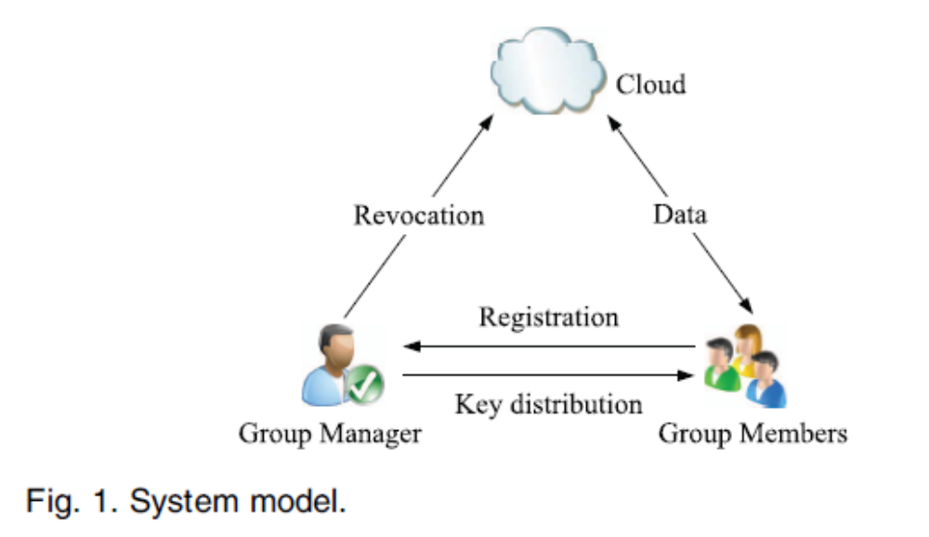
ALGORITHMS USED:

- Signature Generation
- Signature Verification
- Revocation Verification
MODULES:
1.Cloud Module
2.Group Manager Module
3.Group Member Module
4.File Security Module
5.Group Signature Module
6. User Revocation Module .

MODULES DESCRIPTION:

1.Cloud Module :
In this module, we create a local Cloud and provide priced abundant storage services. The users can upload their data in the cloud. We develop this module, where the cloud storage can be made secure. However, the cloud is not fully trusted by users since the CSPs are very likely to be outside of the cloud users’ trusted domain. Similar to we assume that the cloud server is honest but curious. That is, the cloud server will not maliciously delete or modify user data due to the protection of data auditing schemes, but will try to learn the content of the stored data and the identities of cloud users.

2.Group Manager Module :
Group manager takes charge of followings,
1. System parameters generation,
2. User registration,
3. User revocation, and
4. Revealing the real identity of a dispute data owner.
Therefore, we assume that the group manager is fully trusted by the other parties. The Group manager is the admin. The group manager has the logs of each and every process in the cloud. The group manager is responsible for user registration and also user revocation too.

3.Group Member Module :
Group members are a set of registered users that will
- store their private data into the cloud server and
- Share them with others in the group.

Note that, the group membership is dynamically changed, due to the staff resignation and new employee participation in the company. The group member has the ownership of changing the files in the group. Whoever in the group can view the files which are uploaded in their group and also modify it. The group meme

4.File Security Module :
1. Encrypting the data file.
2. File stored in the cloud can be deleted by either the group manager or the data owner.
(i.e., the member who uploaded the file into the server).

5.Group Signature Module :
A group signature scheme allows any member of the group to sign messages while keeping the identity secret from verifiers. Besides, the designated group manager can reveal the identity of the signature’s originator when a dispute occurs, which is denoted as traceability.

6. User Revocation Module :
User revocation is performed by the group manager via a public available revocation list (RL), based on which group members can encrypt their data files and ensure the confidentiality against the revoked users.
SYSTEM REQUIREMENTS:
HARDWARE REQUIREMENTS:
- System : Pentium IV 2.4 GHz.
- Hard Disk : 40 GB.
- Monitor : 15 inch VGA Colour.
- Mouse : Logitech Mouse.
- Ram : 512 MB
- Keyboard : Standard Keyboard

SOFTWARE REQUIREMENTS:
- Operating System : Windows XP.
- Coding Language : JAVA/JSP
- Database : MYSQL
- Server : Apache Tomcat
REFERENCE:
Xuefeng Liu, Yuqing Zhang,Member, IEEE, Boyang Wang, and Jingbo Yan “Mona: Secure Multi-Owner Data Sharing for Dynamic Groups in the Cloud” - IEEE TRANSACTIONS ON PARALLEL AND DISTRIBUTED SYSTEMS, VOL. 24, NO. 6, JUNE 2013.

